Camera Tool to Hide and Reveal Text

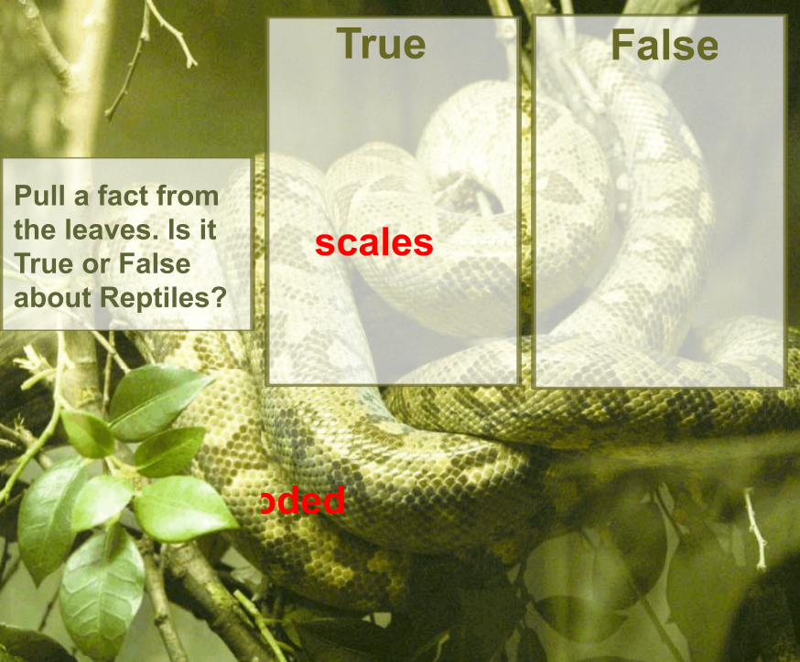

- Find a background to put on the page. (You can also use a picture and enlarge it to the size of the page if you cannot find the right background. Just don’t forget to lock the image down)

- Next select the shapes tool to create the boxes.
  - Draw one box out on the page and then with the select tool tap on the box.
  - This will bring up the editing boxes. 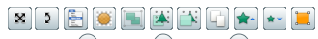
  - Select the (Sun) “Translucency Slider” and slide it over slightly so the box will allow the background to show through.
  - Then duplicate the box so that there are two or as many as you need.
- Next click on the text tool and start typing the content for your page.
- Once all the text is on the page grab the camera tool. Tools > Camera > Area Snapshot. Then take a picture of the area where you want to hide your objects.

- Last, lock your picture or any other boxes that need to be locked. This can be done in the Menu or you can use the Object Browser.
